Create Java API's fast and simple

Chapter 1: Introduction to Java API's



Lecture 1: Introduction

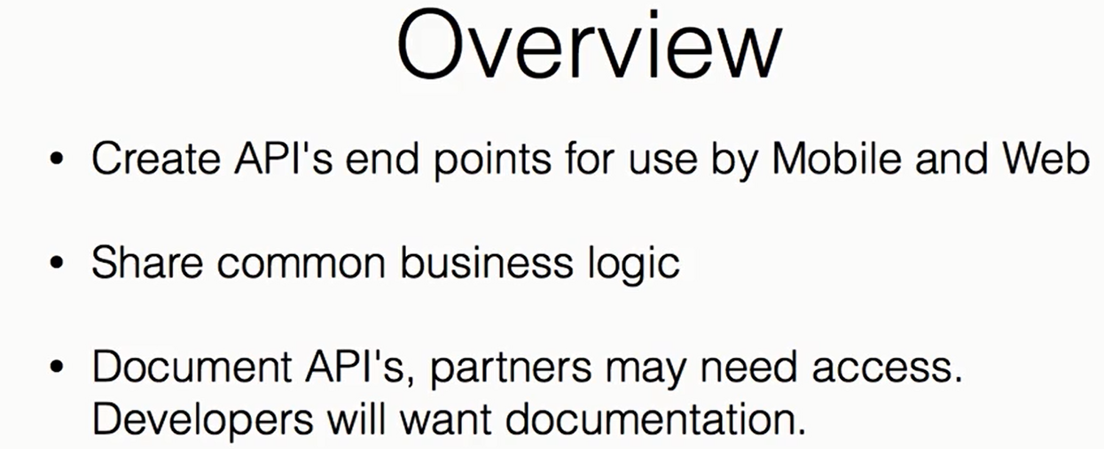

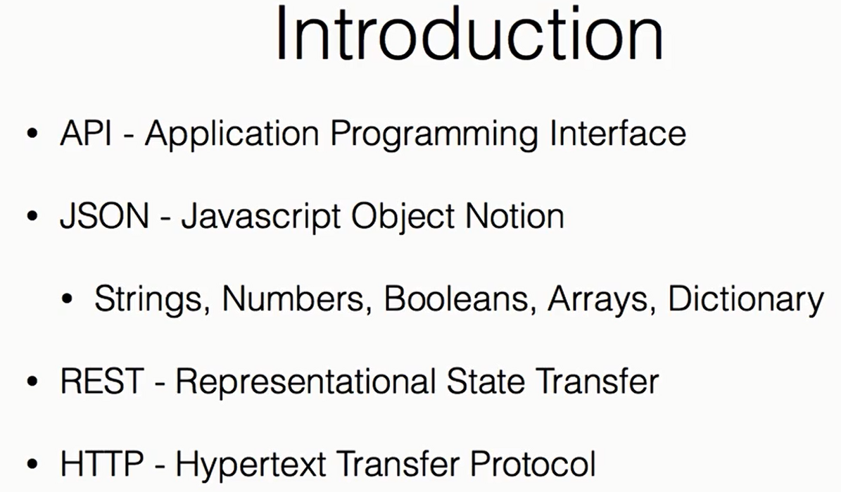

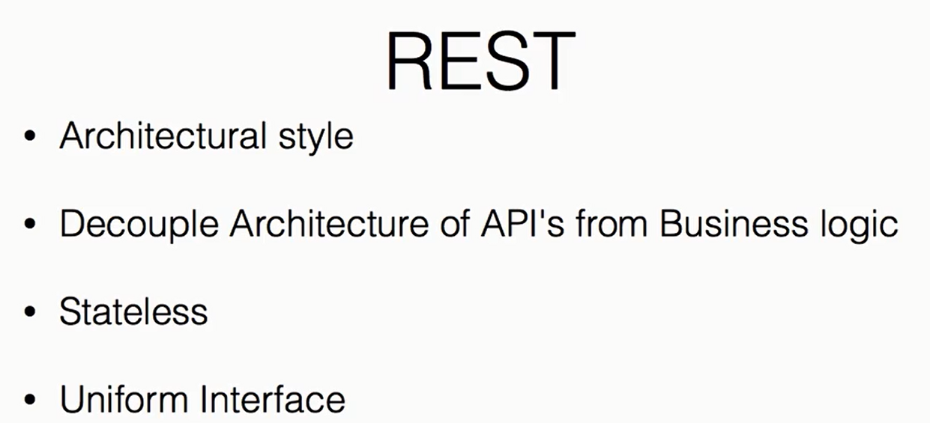

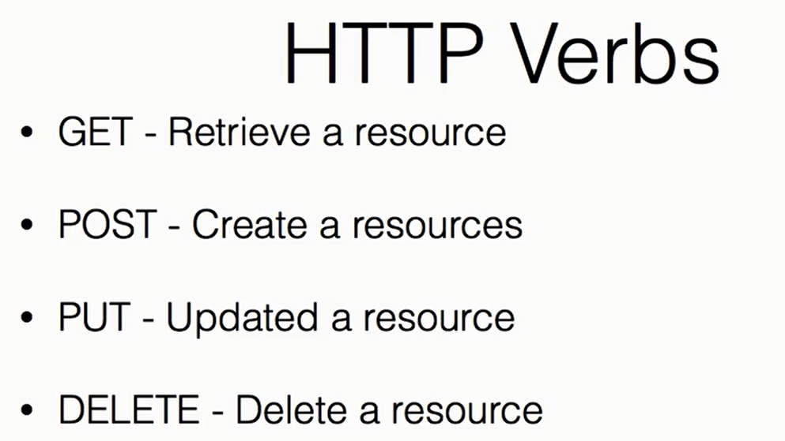

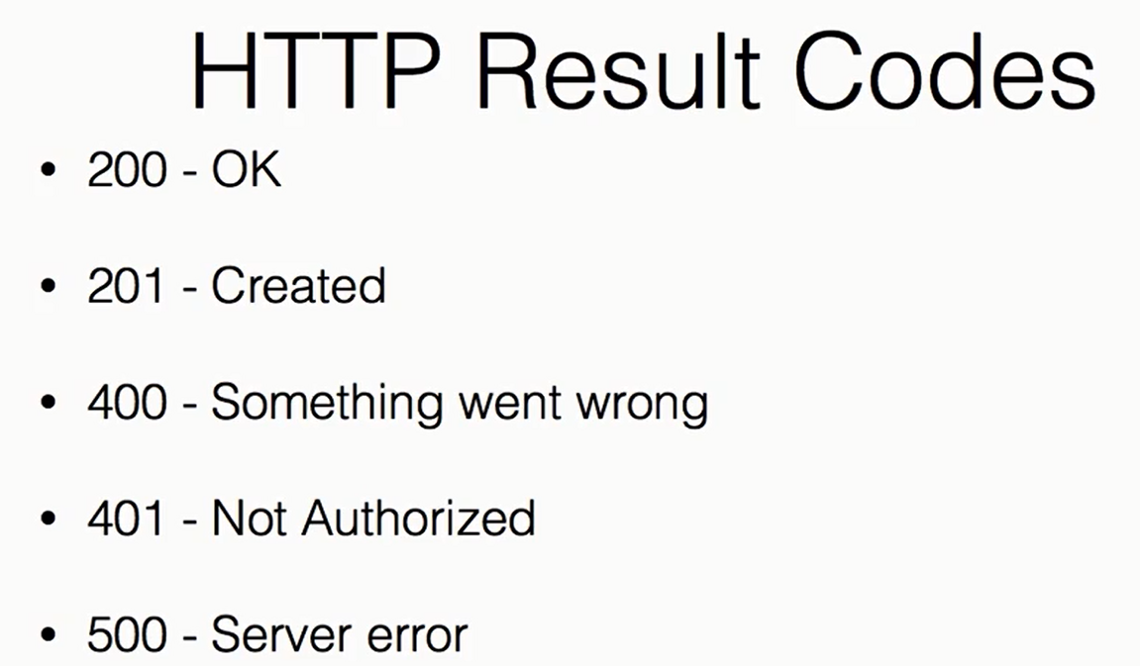

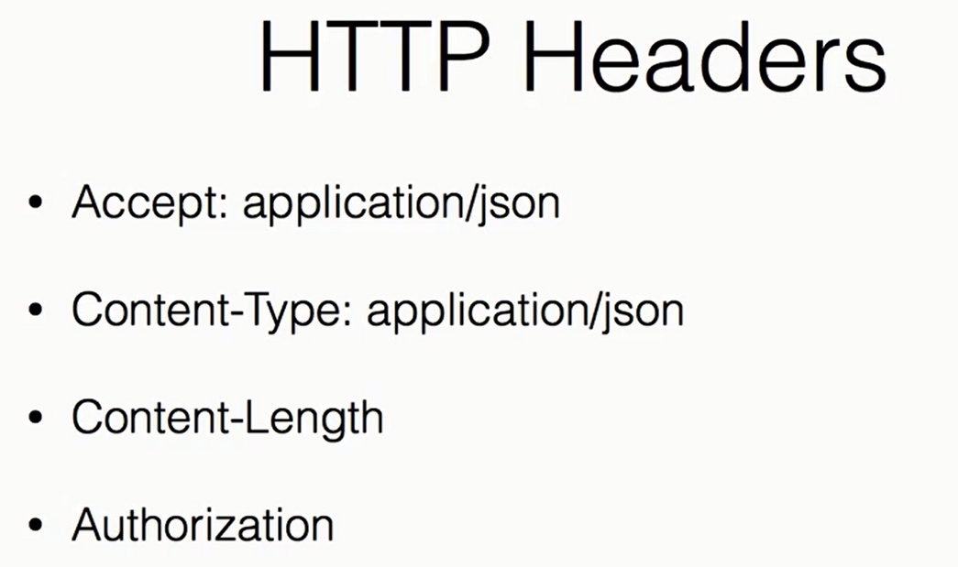

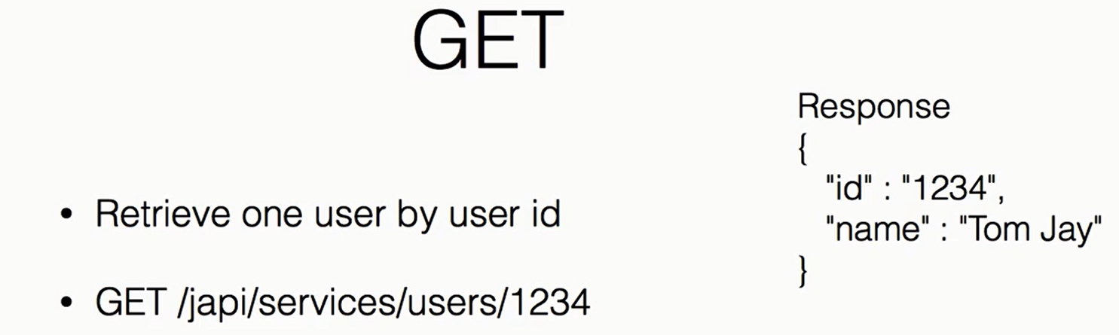

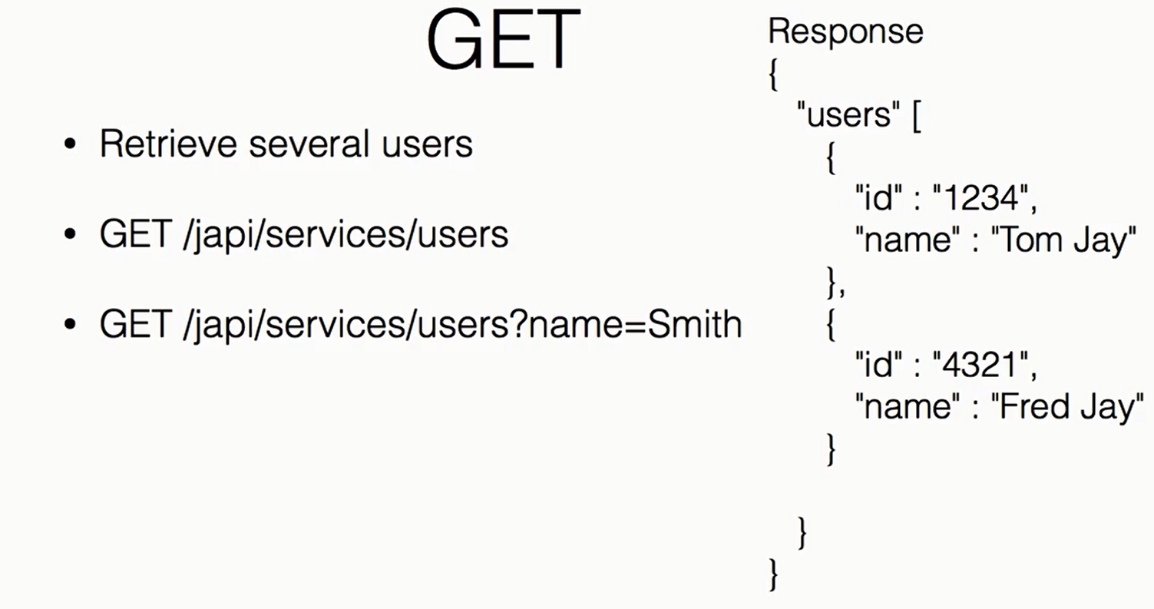

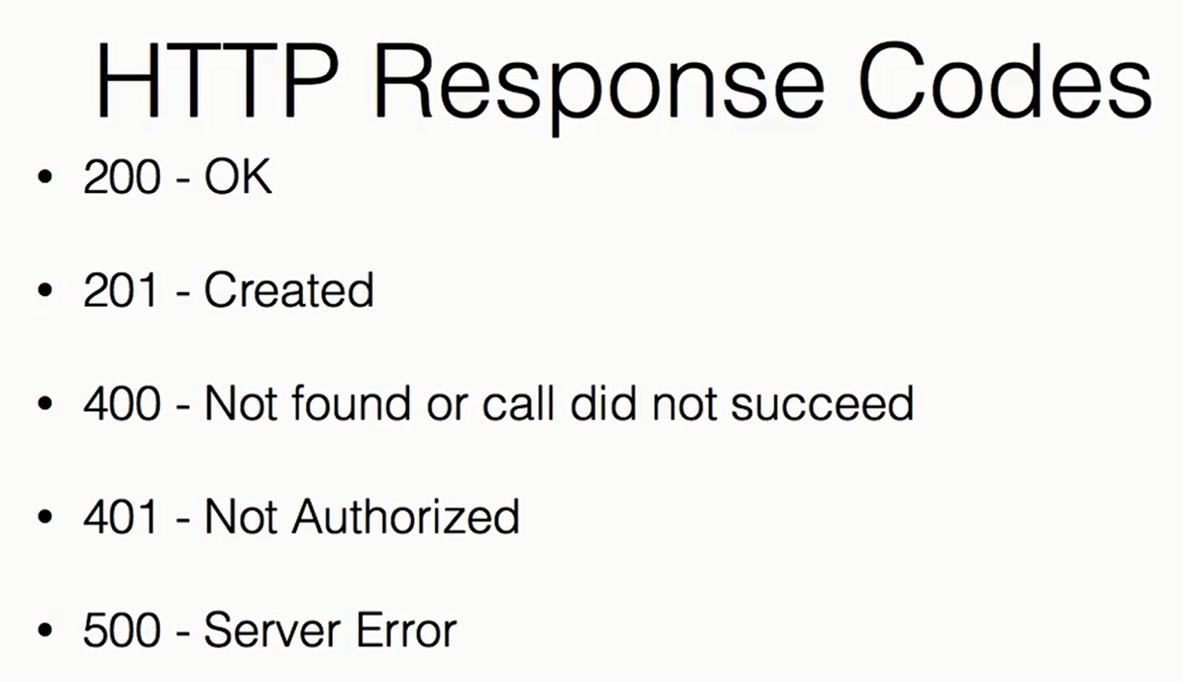

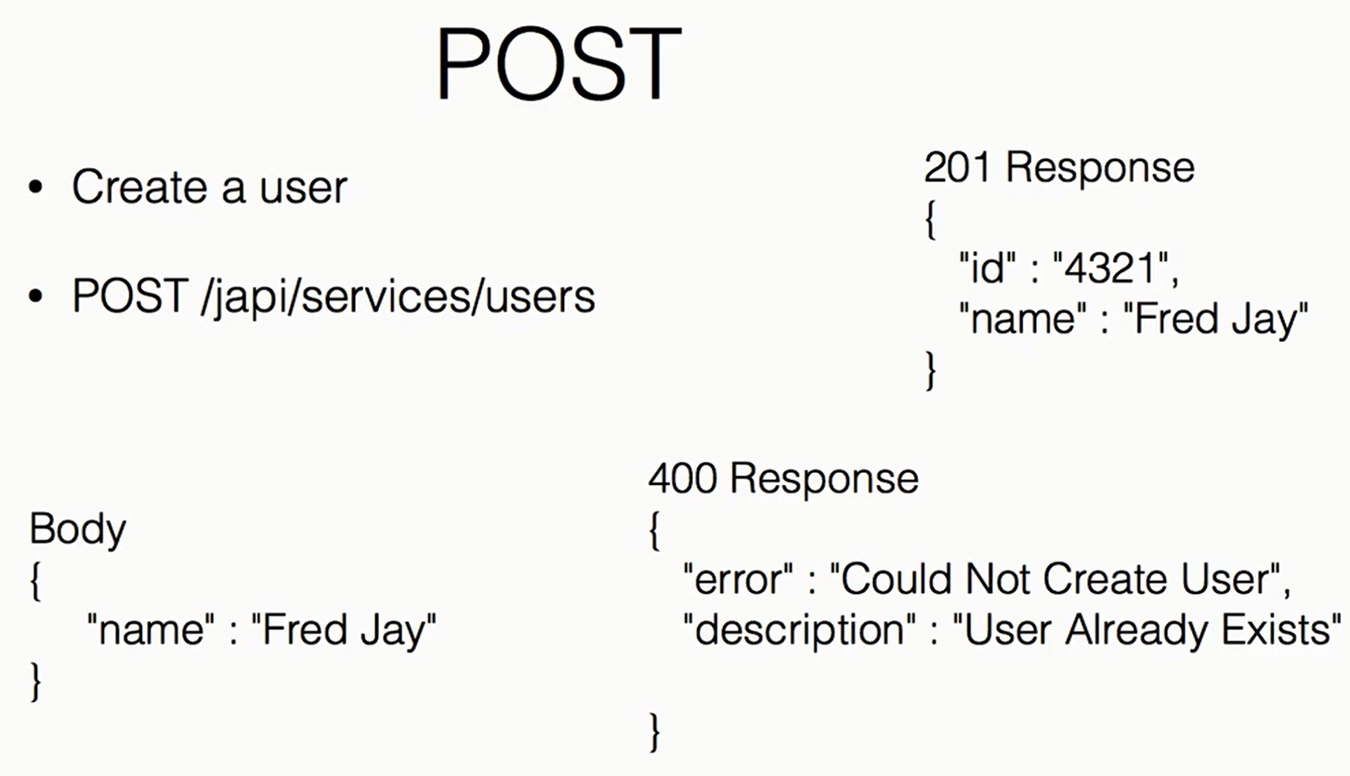

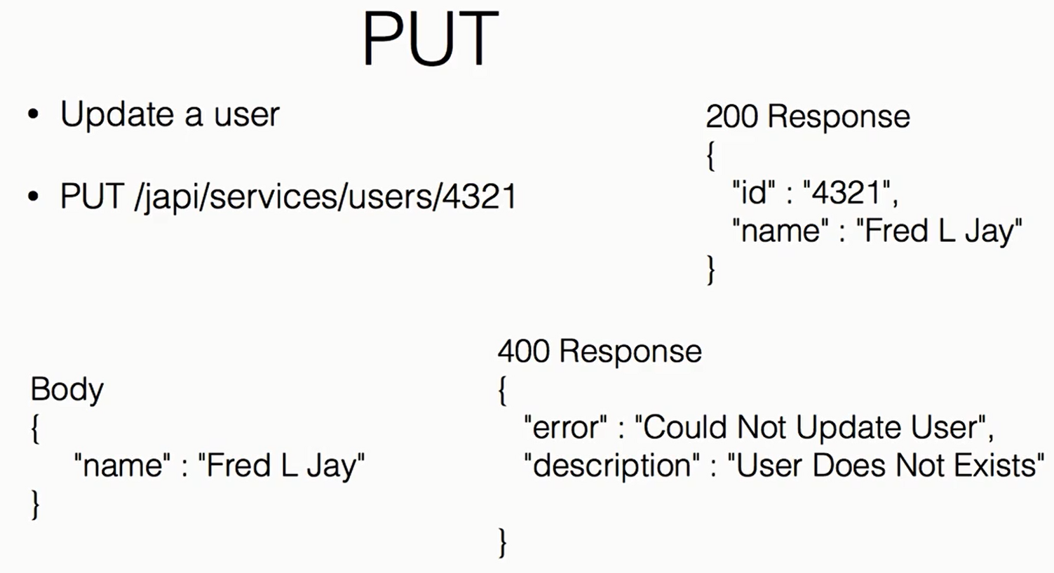

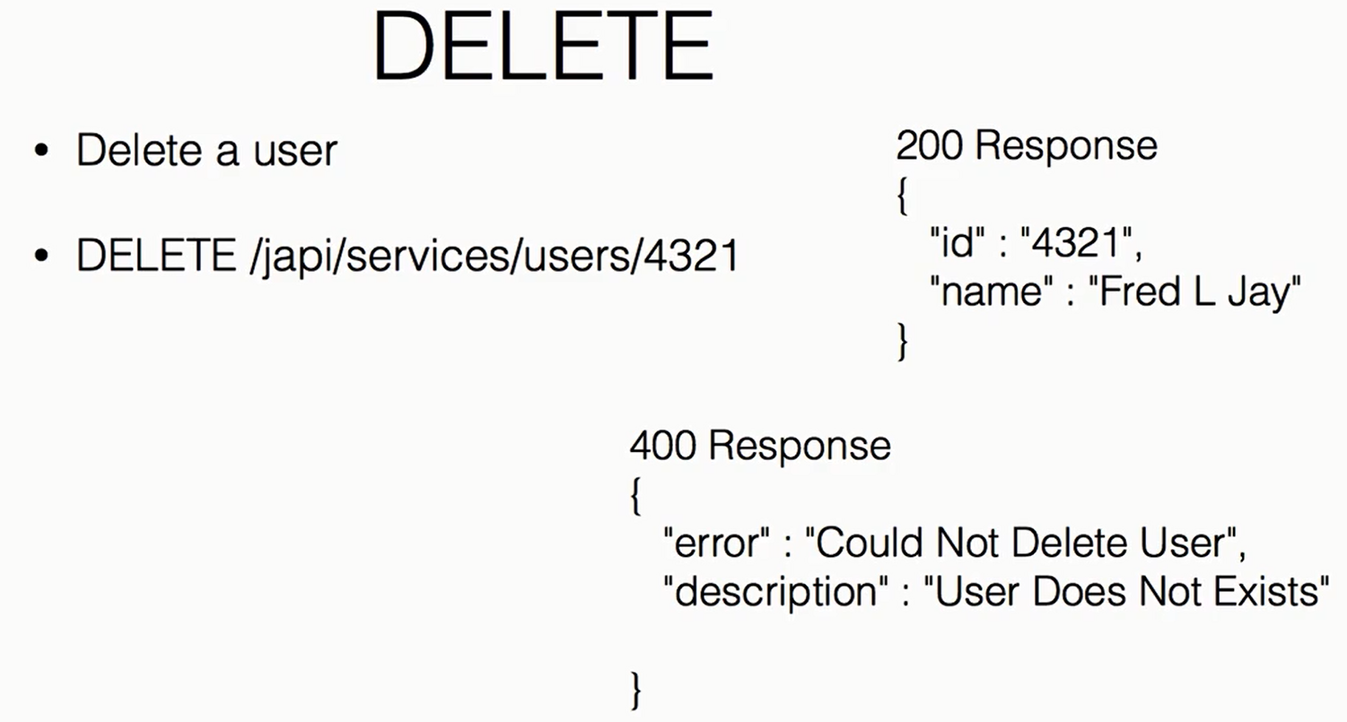

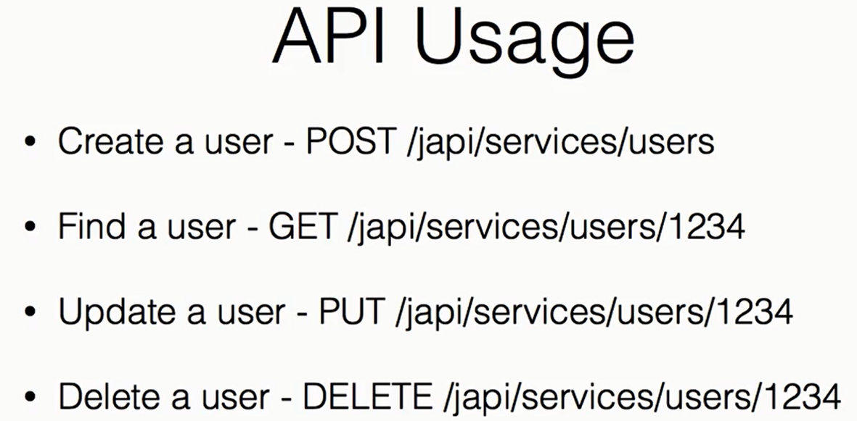

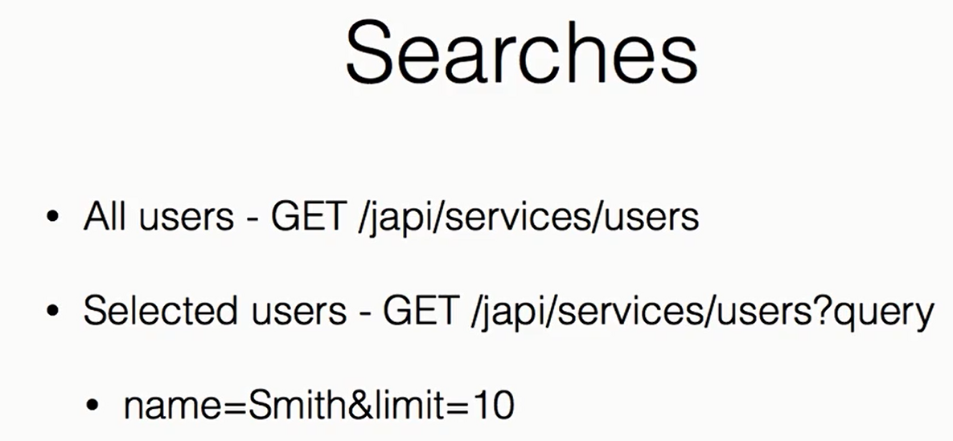

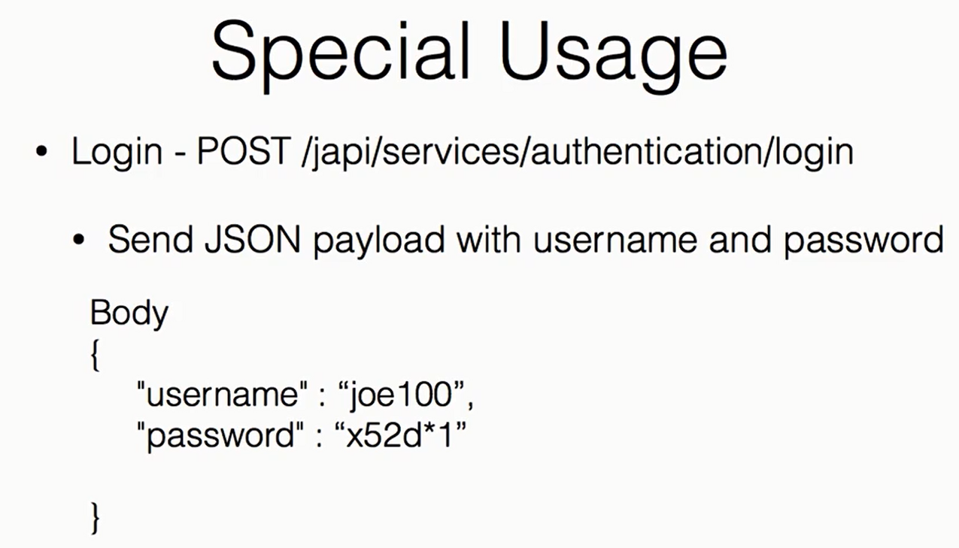

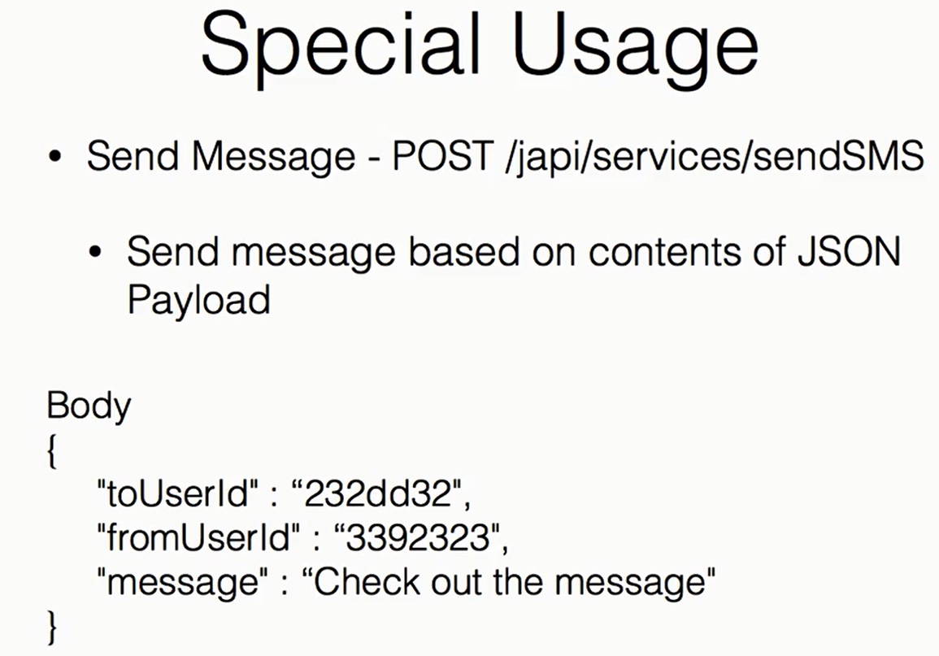

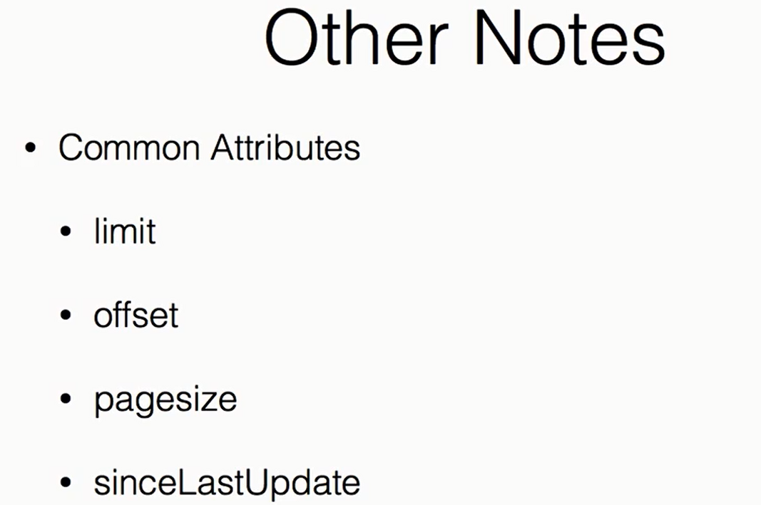

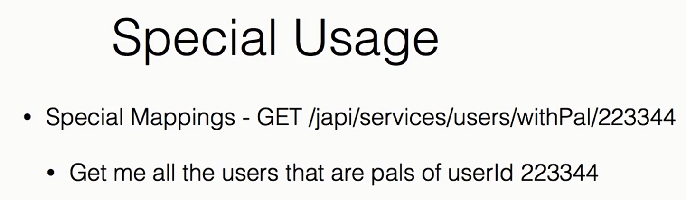

Chapter 2: What is needed

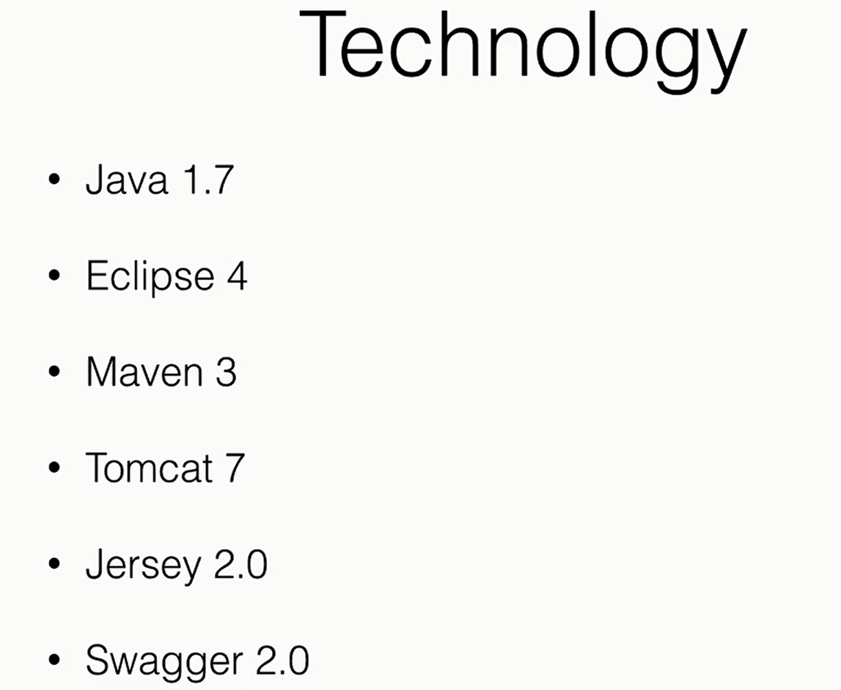

Lecture 2: Getting setup

Add New Maven web project

To remove the following Error:

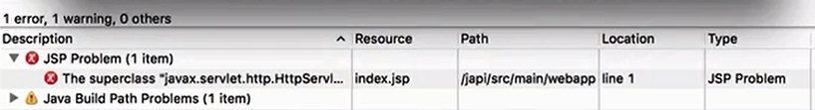

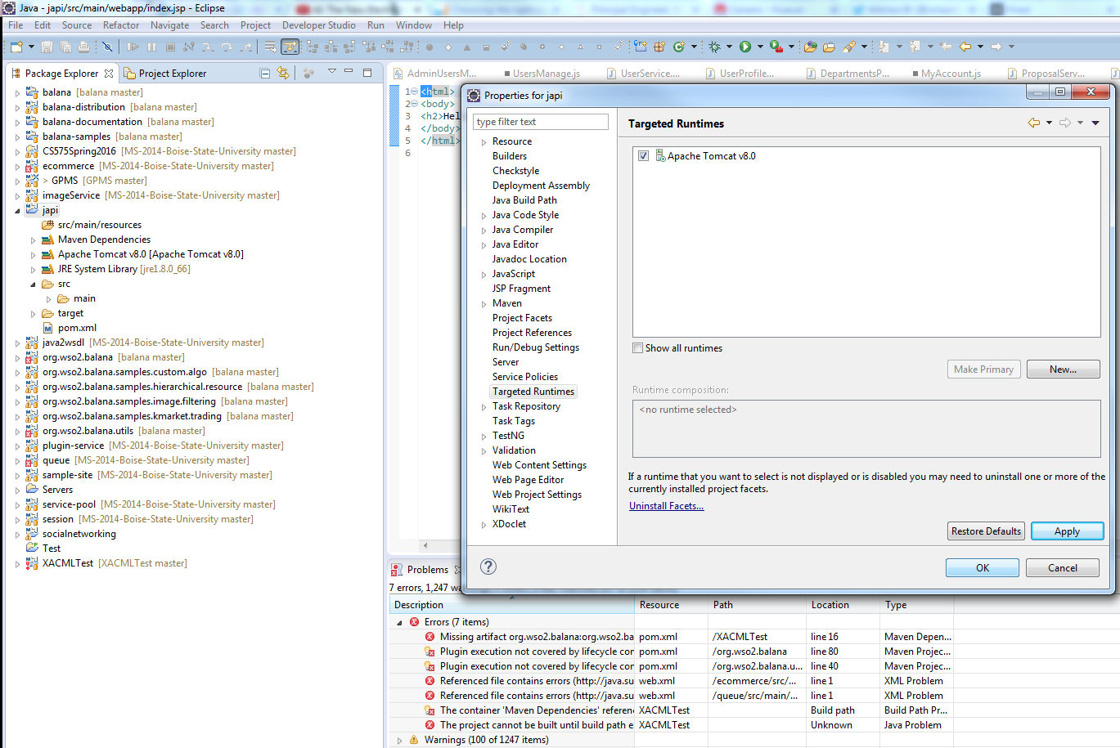

Chapter 3: Start Coding

Adding Swagger dependecy to pom.xml

<https://github.com/swagger-api/swagger-core/wiki/Swagger-Core-Jersey-2.X-Project-Setup-1.5>

<dependency>

<groupId>io.swagger</groupId>

<artifactId>swagger-jersey2-jaxrs</artifactId>

<version>1.5.0</version>

</dependency>

Modify web.xml

Before that need to add few resources in:

Project Explore >> Properties >> Build Path

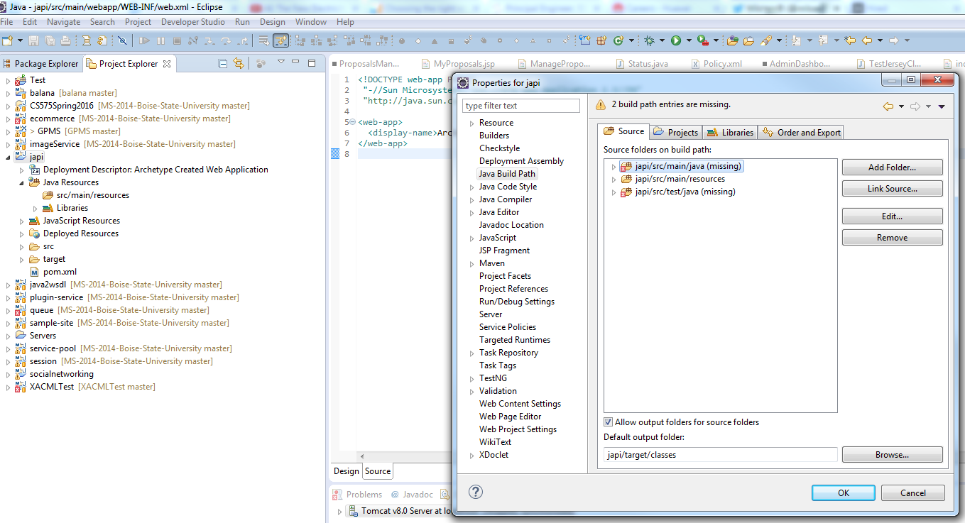

Create those resource folders:

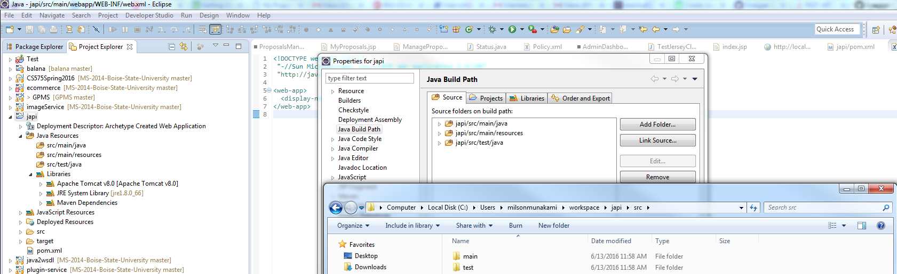

Now the errors will be gone:

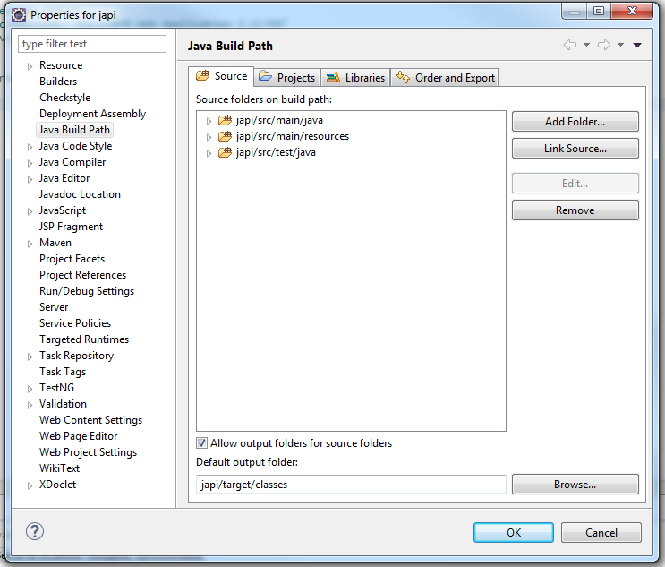

Lecture 3: Starting your project

Create a base package class: 

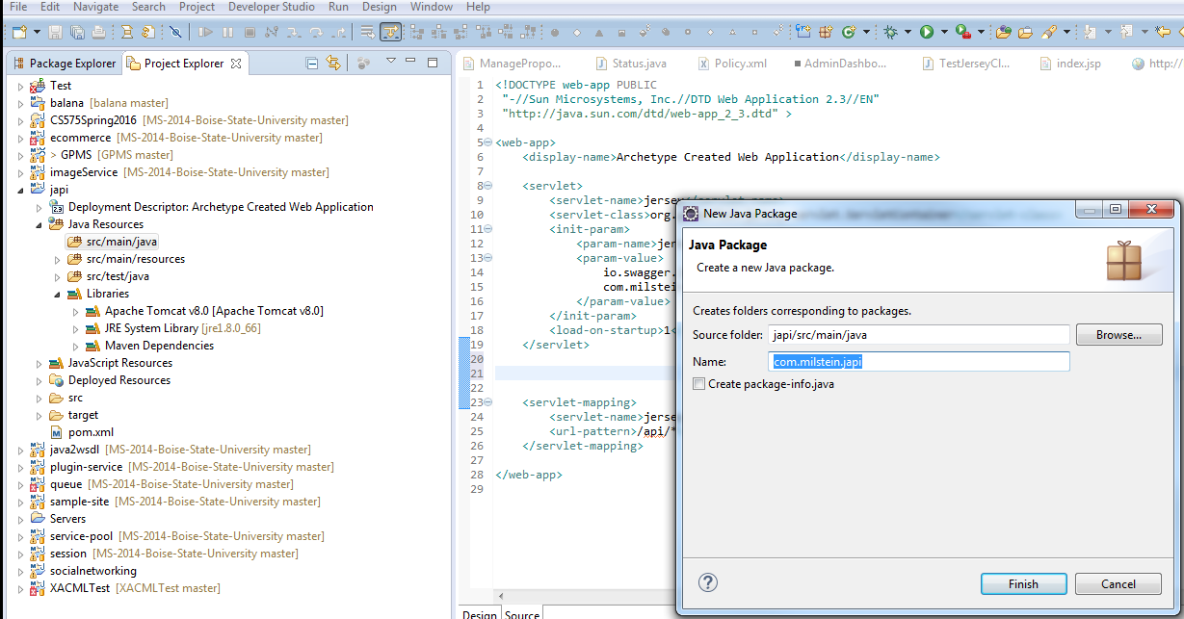

#### Using a Servlet

### Using Swagger's BeanConfig

Swagger's BeanConfig class allows you to set various properties for Swagger's initialization.

| **Method** | **Property Name** | **Purpose** |
| --- | --- | --- |
| setTitle(String) | title | Sets the title of the application. |
| setDescription(String) | description | Sets the description of the application. |
| setTermsOfServiceUrl(String) | termsOfServiceUrl | Sets the URL of the application's Terms of Service. |
| setContact(String) | contact | Sets the contact information for the application. |
| setLicense(String) | license | Sets the license of the application. |
| setLicenseUrl(String) | licenseUrl | Sets the licesne url of the application. |
| setVersion(String) | version | Sets the version of the API. |
| setSchemes(String[]) | schemes | Sets the schemes for the API URLs (http, https). |
| setHost(String) | host | Sets the host (including a port) for the API URLs. Does not include the schemes nor context root. |
| setBasePath(String) | basePath | Sets the context root for the API calls. |
| setFilterClass(Sting) | filterClass | Sets a security filter for Swagger's documentation. |
| setResourcePackage(String) | resourcePackage | Sets which package(s) Swagger should scan to pick up resources. If there's more than one package, it can be a list of comma-separated packages. |
| setScan(boolean) | scan | When set to true, Swagger will build the documentation. |
| setPrettyPrint(boolean) | prettyPrint | Sets whether the swagger.json will be pretty printed. |

In order for the Swagger to operate properly, you must set the base path of the application.

In order for Swagger to actually produce the documentation, you must setScan(true).

The BeanConfig should be called when your application starts up. The two common use cases are either using a Servlet or the Application class if you're already using one. Otherwise, any other method you use at your application's initialization could work.

Add New Class for documentation setup:

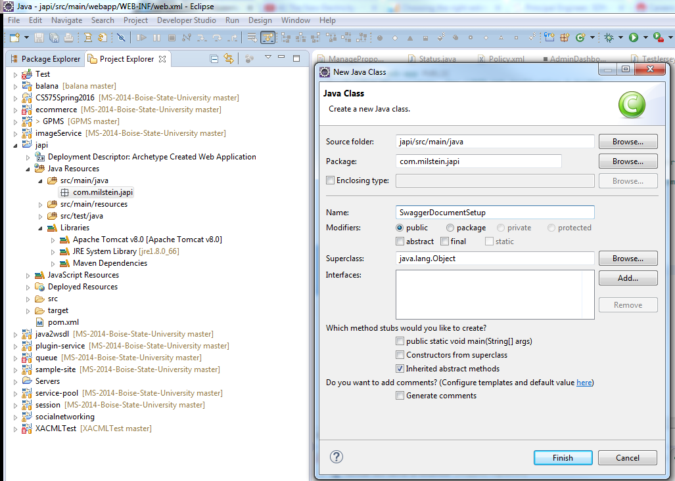

A sample servlet would be:

package io.swagger.api.util;

import javax.servlet.ServletConfig;

import javax.servlet.ServletException;

import javax.servlet.http.HttpServlet;

public class Bootstrap extends HttpServlet {

@Override

public void init(ServletConfig config) throws ServletException {

super.init(config);

BeanConfig beanConfig = new BeanConfig();

beanConfig.setVersion("1.0.2");

beanConfig.setSchemes(new String[]{"http"});

beanConfig.setHost("localhost:8002");

beanConfig.setBasePath("/api");

beanConfig.setResourcePackage("io.swagger.resources");

beanConfig.setScan(true);

}

}

And adding the following snippet to the web.xml will ensure the initialization of Swagger:

<servlet>

<servlet-name>SwaggerBootstrap</servlet-name>

<servlet-class>io.swagger.api.util.Bootstrap</servlet-class>

<load-on-startup>2</load-on-startup>

</servlet>

There's no need for a URL mapping for this servlet as it is only used to initialize the application.

**OR,**

### Using Swagger's Servlet in the web.xml

Swagger offers a simple Servlet that can be used to initialize it.

Add the following snippet to your web.xml:

<servlet>

<servlet-name>Jersey2Config</servlet-name>

<servlet-class>io.swagger.jersey.config.JerseyJaxrsConfig</servlet-class>

<init-param>

<param-name>api.version</param-name>

<param-value>1.0.0</param-value>

</init-param>

<init-param>

<param-name>swagger.api.basepath</param-name>

<param-value>http://localhost:8080/api</param-value>

</init-param>

<load-on-startup>2</load-on-startup>

</servlet>

A few things to note:

1. The api.version should reflect the version of your own API.
2. swagger.api.basepath should point to the context root of your API. This defers from server to server and how you configured your JAX-RS application.
3. There's no <servlet-mapping> for this servlet as it is only used for initialization and doesn't actually expose any interface.

**You are done with this guide! You should now be able to access the Swagger definition at/swagger.json and /swagger.yaml at the context root of your application.**

**i.e. http://localhost:8181/japi/swagger.json**

Lecture 4: The first service

Create a new class inside new package as:

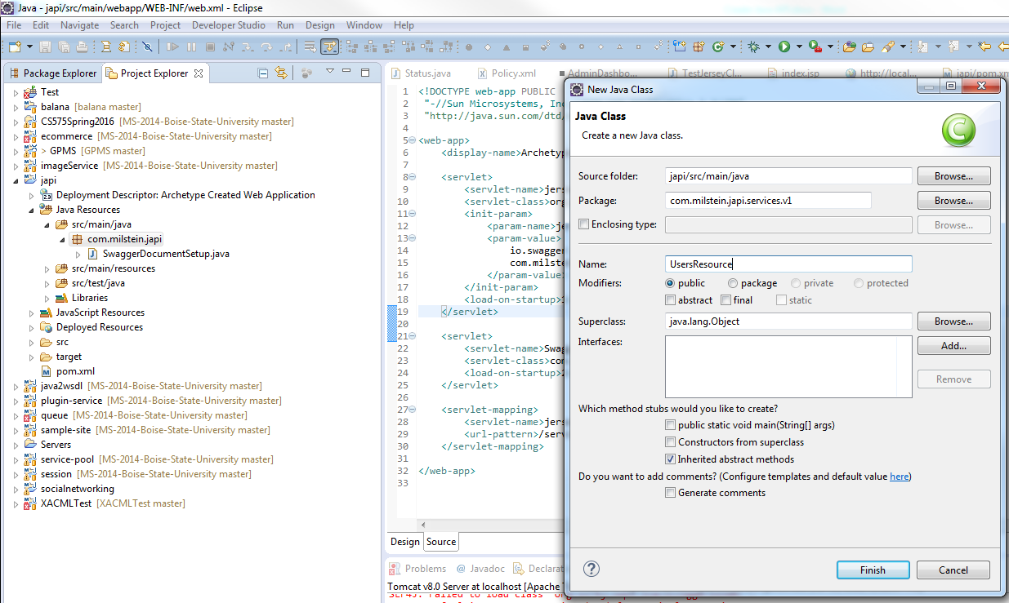

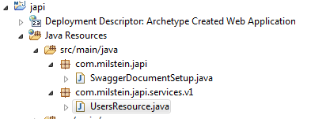

Adding new REST endpoint:

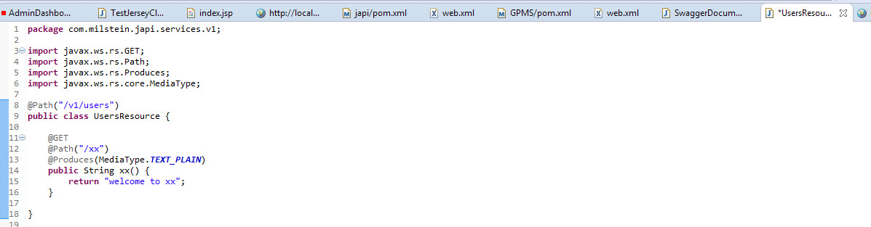

Test:

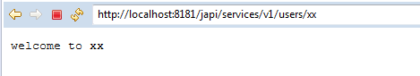

Lecture 5: Getting more formal

So web.xml becomes:

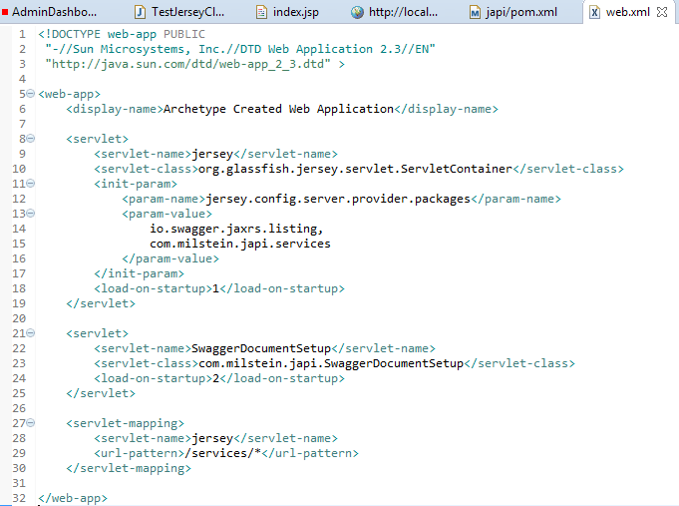

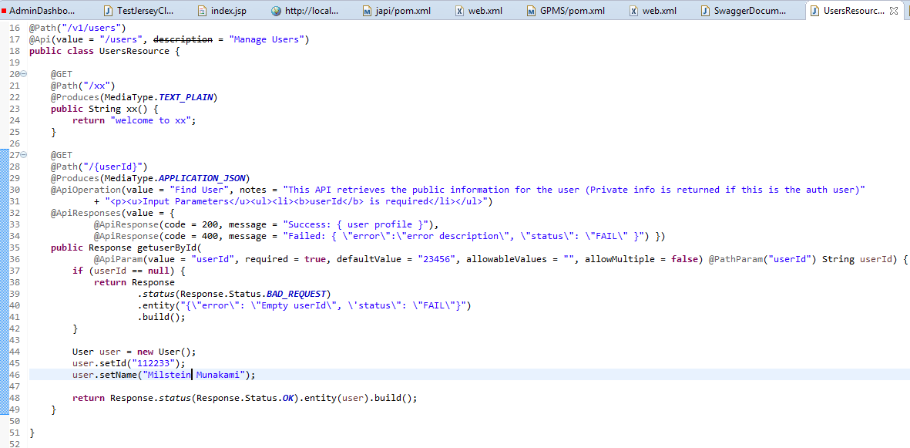

Lecture 6: Making it real

Update the SwaggerDocumentSetup class:

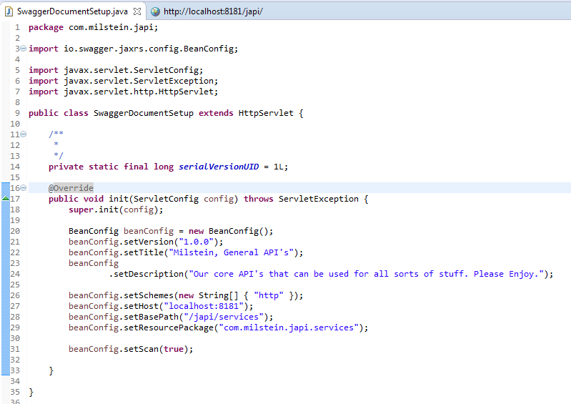

<http://localhost:8181/japi/services/swagger.json>



To turn off Javascript validator:

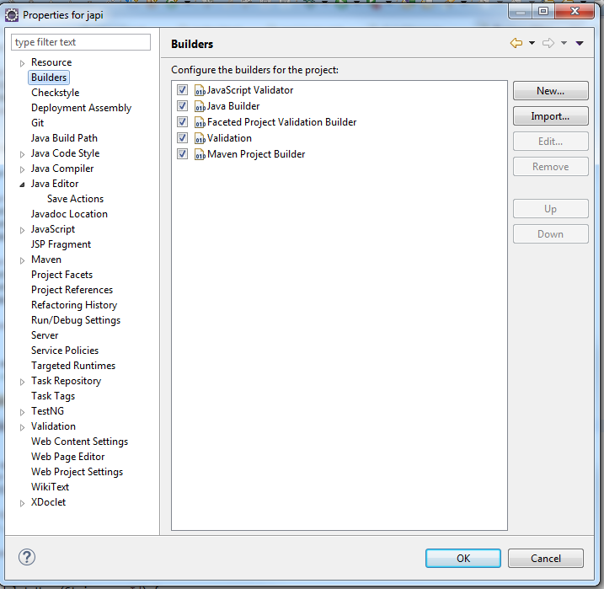

Go to Swagger UI github repo and download:

<https://github.com/swagger-api/swagger-ui/tree/v2.1.4>

copy all ***dist*** folder’s contain from the zip download to the webapp/api-docs folder

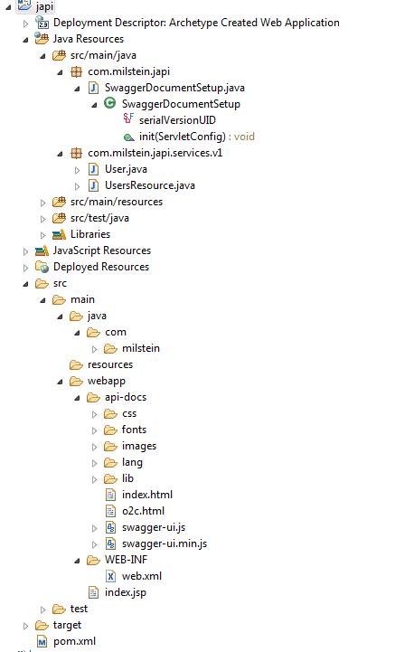

Update the index.html:

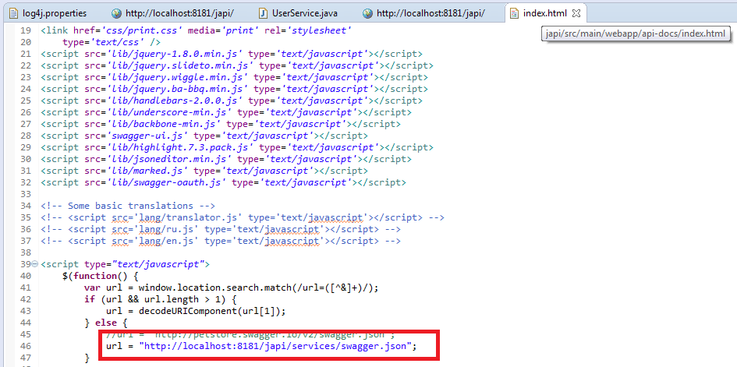

Lecture 7: Adding log4j

Adding dependencies in pom.xml:

<!-- http://mvnrepository.com/artifact/log4j/log4j -->

<dependency>

<groupId>log4j</groupId>

<artifactId>log4j</artifactId>

<version>$(version.log4j)</version>

<exclusions>

<exclusion>

<groupId>com.sun.jax</groupId>

<artifactId>jmxri</artifactId>

</exclusion>

<exclusion>

<groupId>com.sun.jdmk</groupId>

<artifactId>jmxtools</artifactId>

</exclusion>

<exclusion>

<groupId>javax.jms</groupId>

<artifactId>jms</artifactId>

</exclusion>

</exclusions>

</dependency>

Add log4j.properties file:

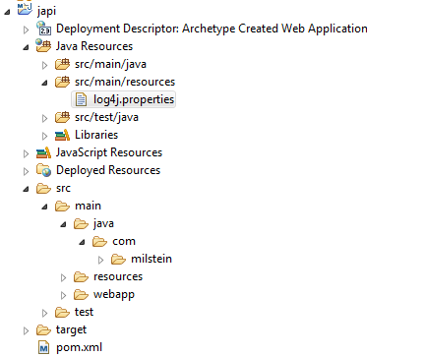

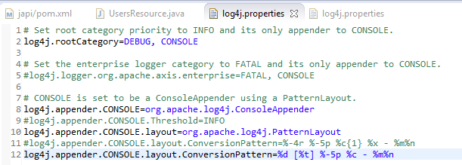

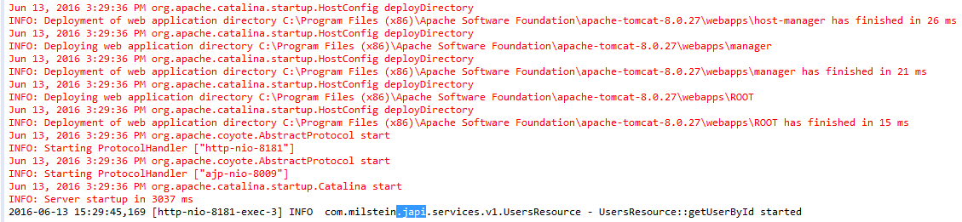

Lecture 8: Business management

Add BusinessManager class in api package and make it a Singleton Instance!

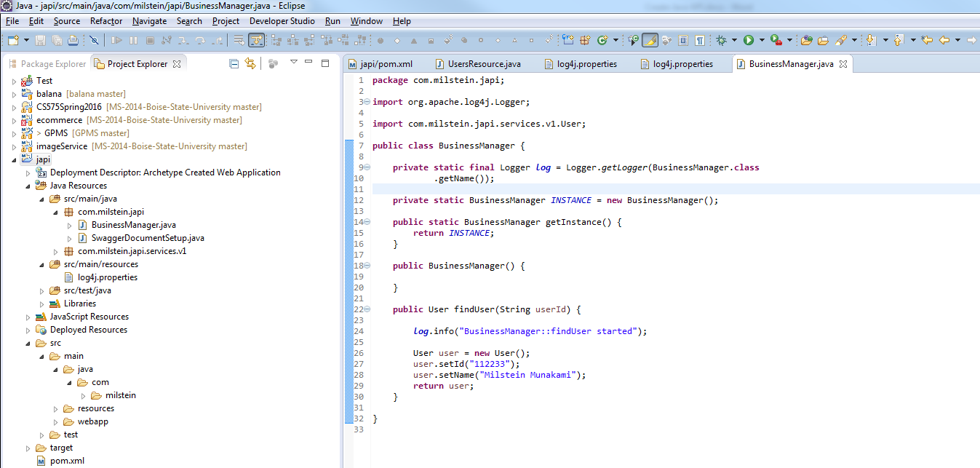

Remove the static code from the UserResource class :

1. Get User By Id():

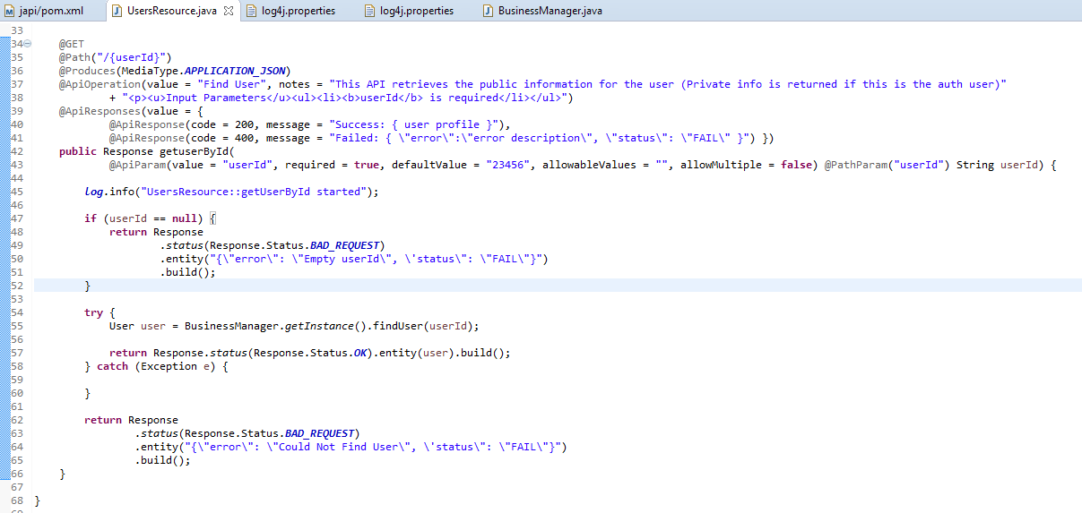

Both classes have log info logged with log4j and we can see following console output:

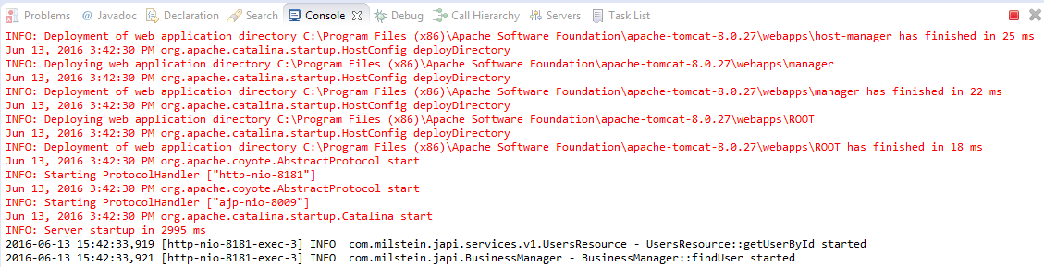

Lecture 9: All API's





1. Add findUsers () Method:

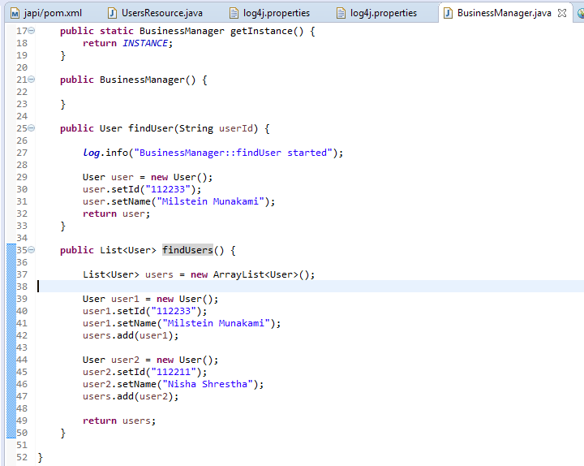

Add new class to hold the list of Users:

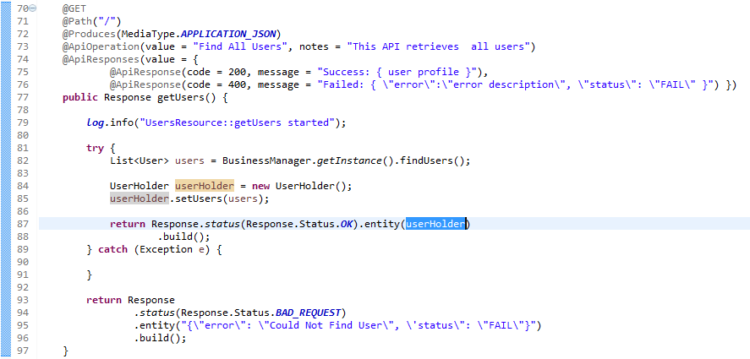

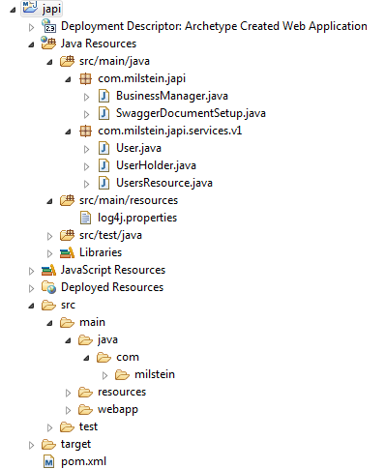

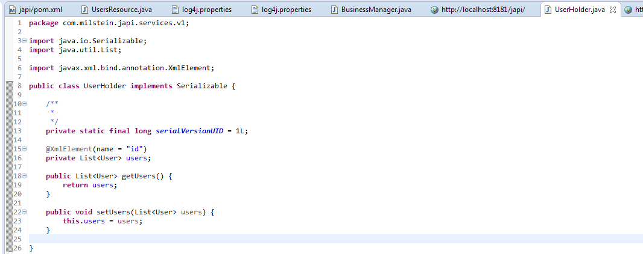

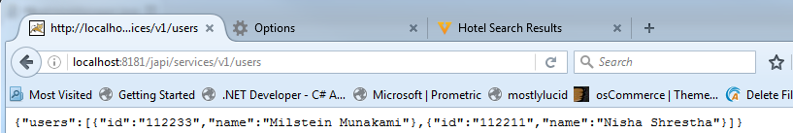

1. POST a New User :

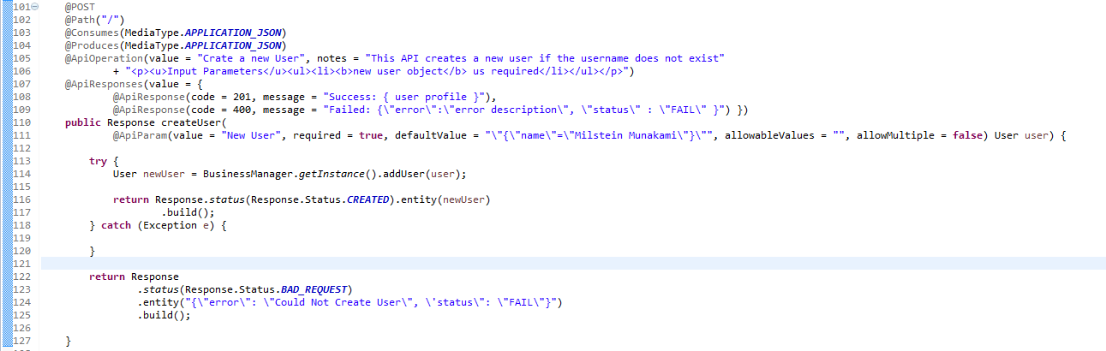

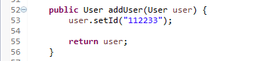

1. Update the User:

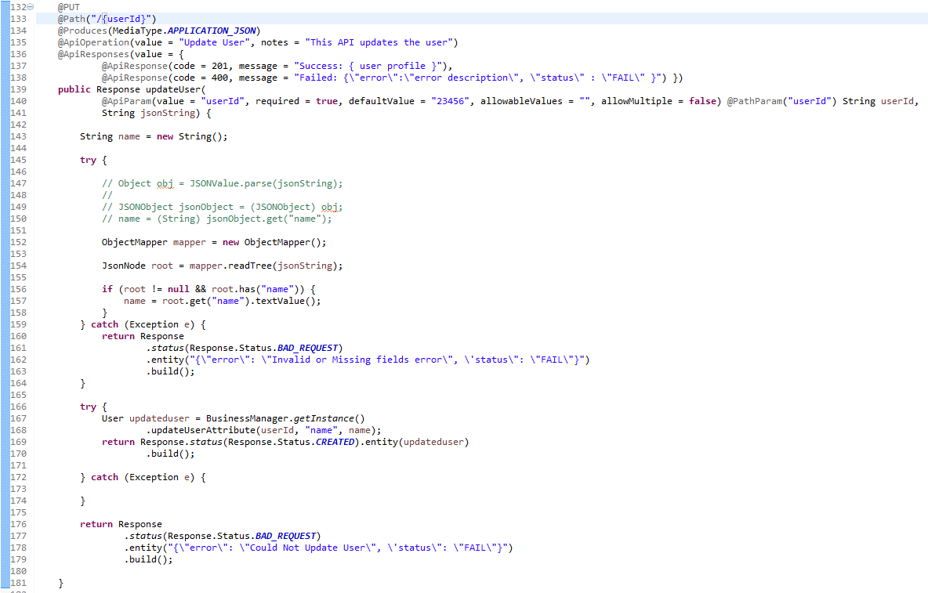

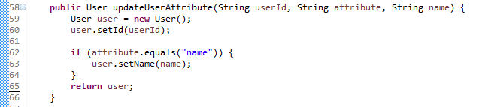

1. Delete a User:

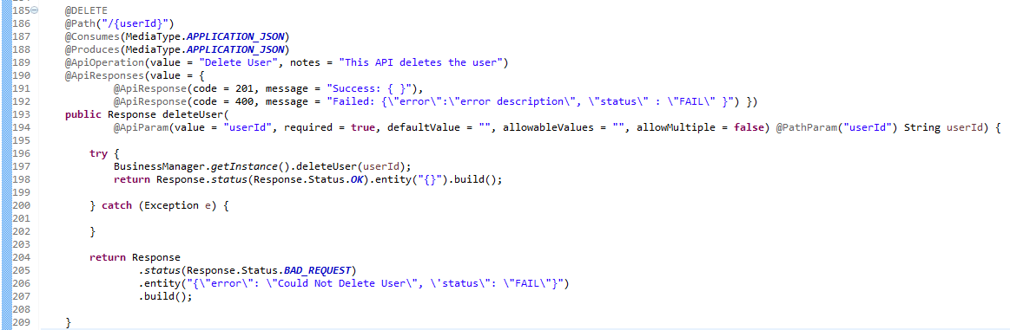



Chapter 4: Database

Lecture 10: MongoDB Integration

1. Add pom.xml dependency for MongoDB-java-driver
2. Create a DB Connector class 🡪 DataManager
3. Make it singleton:

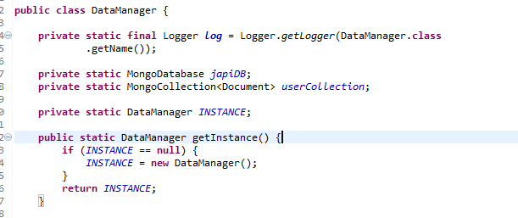

It includes logger, database and collection instances.

1. Initialize the MongoClient One of many ways to do so:

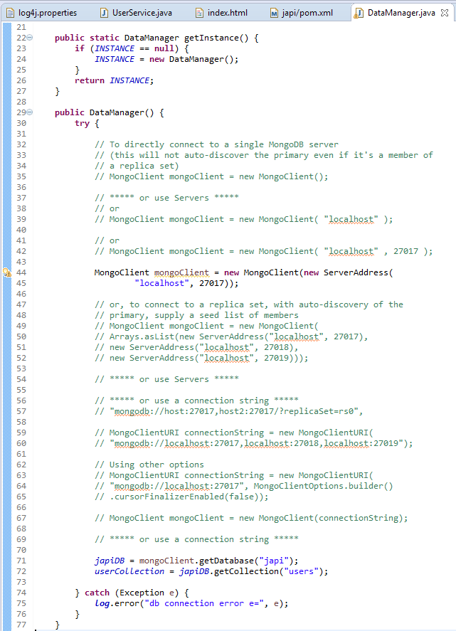

1. Insert a new User:

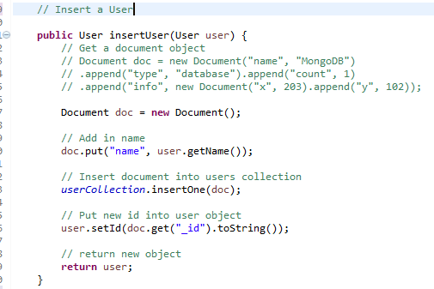

How to call it:

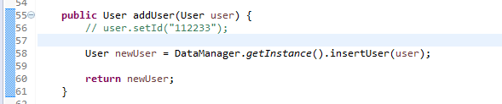

Lecture 11: Database continued

Chapter 5: Production Deployment

Lecture 12: Create a war and installing on a server

Chapter 6: Summary

Lecture 13: Thanks

Lecture 14: Source Code